Muhammad Balal Asar

Week 3 Lab Task
Scanning & Enumeration
NIAI NAVTTC — Certified Ethical Hacker (CEH) Course
⚠ Important: All tasks must be performed only in your isolated virtual lab environment. Never test on real networks or systems without explicit written permission.

Task: Conduct a comprehensive network scan to identify all active hosts and services. Perform vulnerability scanning on identified hosts. Perform active enumeration on a Windows-based network to identify Active Directory users, groups, and systems.

Step 1 — Set Up Your Target VM
▶ Download and Import Metasploitable 2
Go to: sourceforge.net/projects/metasploitable/
Download the Metasploitable 2 zip file and extract it.
In VirtualBox: File → Import Appliance, or just add the .vmdk as a new VM.
Set BOTH Kali and Metasploitable to the same 'Host-Only Adapter' network so they can talk to each other.
Start Metasploitable. Login: msfadmin / msfadmin
Run ifconfig to find its IP address (e.g. 192.168.56.101). Note this IP — you will use it in all commands below.
Step 2 — Network Scanning with Nmap
▶ Ping Sweep — Find Live Hosts
nmap -sn 192.168.56.0/24
This lists all devices that are online on your host-only network.
▶ Full Port Scan with Service Detection
nmap -sV -p- 192.168.56.101
-sV detects service versions. -p- scans all 65535 ports.
▶ OS Detection
nmap -O 192.168.56.101
▶ Vulnerability Scan with Nmap Scripts
nmap --script vuln 192.168.56.101
This runs Nmap's built-in vulnerability detection scripts against the target.
Step 3 — Enumeration
▶ Enumerate Windows / Active Directory (if Windows VM is available)
enum4linux -a 192.168.56.101
This tool extracts users, groups, shares, and policies from Windows/Samba targets.
▶ SMB Enumeration
nmap --script smb-enum-users 192.168.56.101
nmap --script smb-enum-shares 192.168.56.101
▶ Additional Enumeration with Nmap Scripts
nmap --script=nbstat 192.168.56.101 # NetBIOS info
nmap --script=snmp-info 192.168.56.101 # SNMP info
nmap --script=dns-brute 192.168.56.101 # DNS brute force
Step 4 — Document Your Findings
▶ Write a Scan Report
Record the following for each host found:
- IP address and hostname

Scanme.nmap.org
- Open ports and services running
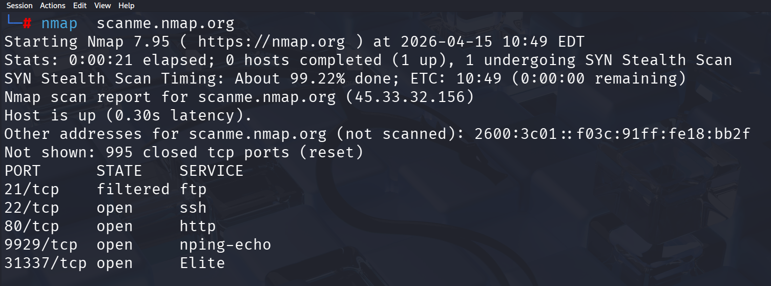

- Operating system detected
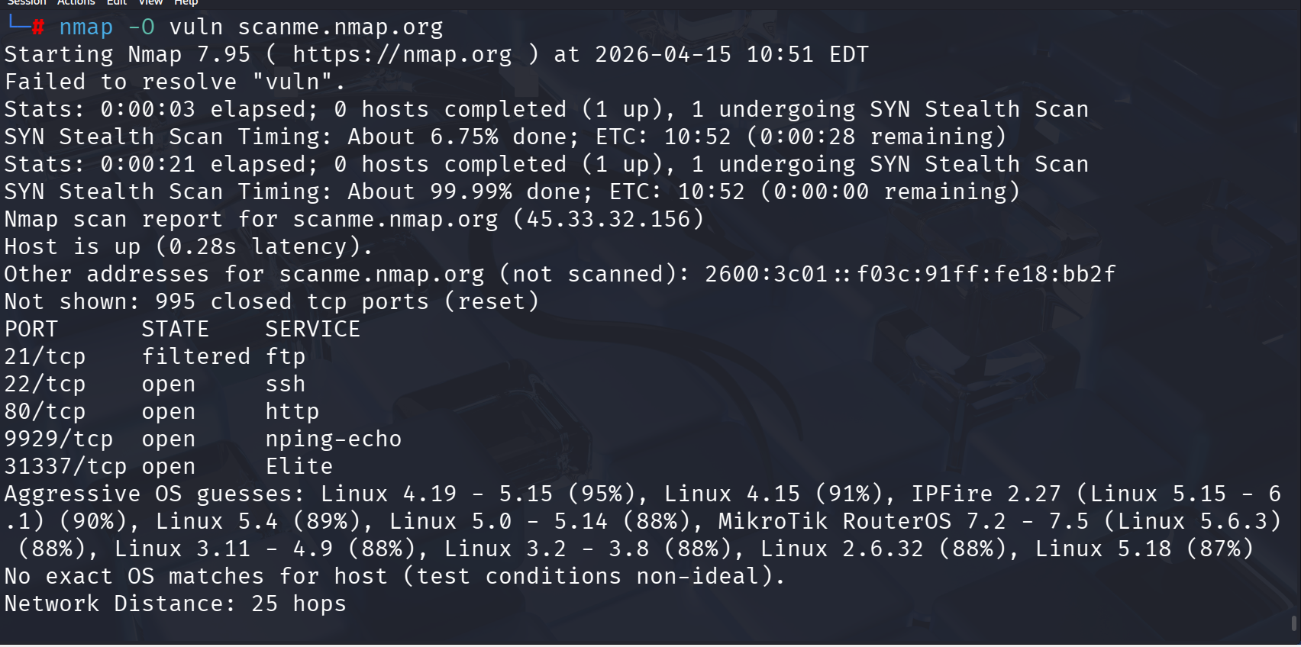
- Any vulnerabilities flagged by Nmap

1. FTP (Port 21 – Filtered)
- FTP is old protocol and often insecure
- Even though filtered, if exposed it can lead to:
  - weak authentication risks
  - credential sniffing (if not encrypted)

2. SSH (Port 22 – Open)
- Secure service but still risky if:
  - weak passwords used
  - brute-force attacks attempted
- Misconfiguration can lead to unauthorized access

3. HTTP (Port 80 – Open)
- Unencrypted web traffic (no HTTPS)
- Risks:
  - data interception
  - injection attacks (if vulnerable web app exists)

4. nping-echo (Port 9929 – Open)
- Diagnostic/testing service
- Not commonly used in production
- Exposure may leak network behavior info
5. Elite (Port 31337 – Open)
- “Leet/Elite” port often used for testing/backdoors in labs
- Can be suspicious if found in real systems
- May indicate:
  - custom service
  - potential misconfiguration or hidden service

- Any users/shares found during enumeration

SMB Service Status:
- Port 445/tcp (SMB) is not open
- Therefore, SMB enumeration could not be fully performed

Users Found:
- No user accounts discovered
- Reason: SMB service not exposed

Shares Found:
- No shared folders detected
- Reason: No SMB shares available on target

🎯 Goal: A complete scan report listing active hosts, open ports, running services, OS info, and enumerated users/shares — with potential vulnerabilities identified.

